BCIS R&D Project
Portfolio and Final Product
Requirements and Assessment
Guide


Date
Version Author
Notes
17 April 2014 1.0
Anne Philpott
Contains collated notes from earlier
project assessment resources.
Minor updates
February
2015
May 2016
1.1
1.2
Anne Philpott
Stephen
Template revision, minor updates
Thorpe
August 2019 1.3
Sarita Pais
Sarita Pais
Sarita Pais
SharePoint digital portfolio
Minor changes to suit online delivery
Assessment weightage
April 2020
Aug 2020
Sep 2022
1.4
1.5
1.6
Jacqui & Ramesh General update
Jan 2023
1.7
Jacqui & Ramesh Added clarification of requirements
that portfolio must be on AUT’s
OneDrive.
Page 2 of 7
Version 1.6
Sep 2022
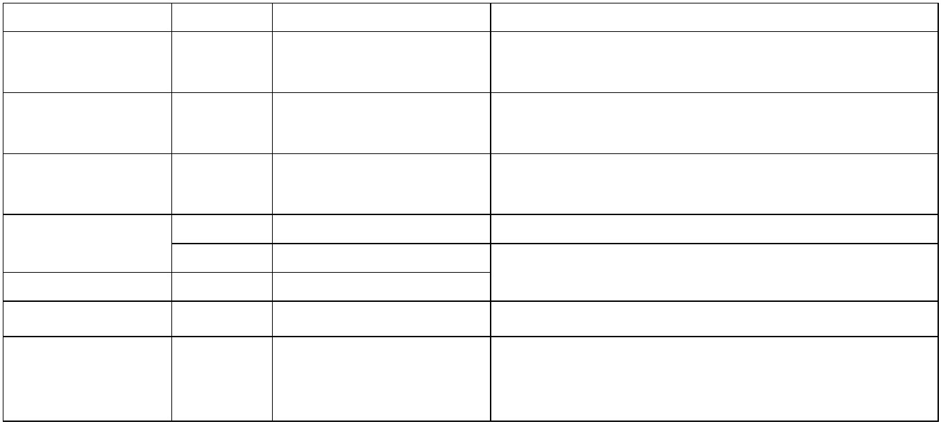

1. Introduction
At the end of your R&D Project, your team will have produced several artefacts that address
the product goal. You and your team will also have plans, diagrams, and documents that were
used to execute (design, create, and test) and monitor your project. These artifacts placed into
your portfolio provide evidence of the work you (individually) and your team (collectively) has
done over the year of your R&D project.
The portfolio must make visible all the team and individual work that went into achieving your
specified project goals and project product/outcomes.
The following Part 2 assessment elements (worth 55%) are marked based on the evidence
provided in the portfolio:
1. Mentor feedback (10%)
2. Project planning and control (10%)
3. Teamwork and communication (10%)
4. Development activities and work products (25%)
The learning goals associated with the portfolio assessment are:
1. Show the ability to undertake original work and demonstrate a professional attitude
successfully.
2. Demonstrate the ability to integrate the different skills required to bring a project to a
successful conclusion.
3. Communicate effectively with clients and sponsors in written and verbal presentations
and group situations.
4. Effectively manage, monitor and control the activities involved in a research and
development project.
5. Determine an appropriate process and accompanying deliverables for their project by
selecting and justifying an appropriate methodology for their project.
6. Show the ability to document the deliverables appropriately for their project (e.g.
software specifications, project plans, source code, technical reports, white papers,
literature reviews, academic articles for publication etc.), as agreed with the project
supervisor(s).
2. Portfolio Expectations
Your team should have commenced compiling the portfolio at the start of the project in Part 1
and continue to archive and curate artifacts in this portfolio as you continued working on your
project during Part 2. The markers will expect to see multiple versions of documents and artefacts as
they are updated and modified in response to changes during the lifetime of your R&D project. For
example, it is likely that your project plan changed as you gained deeper project insight and in this case
the assessors will expect to be able to track those changes by reviewing the different versions of your
teams’ project plan.
Your team will have completed a show/tell presentation of the portfolio during your mid-project
review presentation at the end of Part 1. You should have received feedback from the mid-
project review marking panel and improved your portfolio structure and content based on that
feedback. Please refer to the workshop slides on Canvas (RnD Part 2/ Workshop 1/ Preparing
Final Portfolios) which outlines possible structures for your portfolio and reviews the marking
Page 3 of 7
Version 1.6
Sep 2022


criteria and expectations.
You must ensure that your portfolio’s structure has been confirmed with your mentor and
is suitable for your project.
You must also review the marking criteria and ensure that your portfolio is presenting the
necessary evidence across the key dimensions given in the marking rubric provided in this
document’s Appendix A.
It is your responsibility to ensure that the portfolio’s structure and content is presented in a manner
that makes it easy for the markers and moderators to navigate and that any external tools and
sites linked to in your portfolio (e.g., Trello boards, Online Jupyter notebooks, GitHub repositories
etc.) can be accessed by the markers through provision of marker accounts and passwords etc.
Your team should ensure that these access needs have been discussed with your mentor and
moderator. You must not assume that the markers have a personal account that can be used.
3. Project Products
The products produced will vary depending on the R&D projects. Regardless, the product must
be submitted along with your team's portfolio. Any software/website/app developed requires
all program code and test cases to be submitted
The mentor and moderator must be able to run and test the software/website/app. Please
ensure you discuss this with your mentor to ensure appropriate access rights and passwords
are provisioned. If your mentor and moderator cannot access your team's work, they will not
be able to mark that component of the portfolio.
4. Portfolio Submission
The portfolio and its contents must be provided in a digital format. Each team must submit
their final portfolio via a shared folder using AUT OneDrive before the deadline. Only one
team member is required to create a folder with their AUT OneDrive virtual storage space. It
is essential to use AUT systems for the portfolio to ensure client and student confidentiality in
line with AUT requirements. The team must share this folder with the mentor moderator
and paper leaders via an emailed link on or before the assessment due date and time.
5. Assessment Marking
Your portfolio and the artifacts you have produced are worth 55% of your overall mark. The
final mark sheet is included in Appendix B. To pass the R&D project paper, you must achieve
an overall mark of 50% across all the Part 1 and Part 2 assessments.
Your project mentor and the moderator will mark the portfolio and product. This marking will
happen over the three-week period following submission. The marks allocated to individuals
and teams will then be moderated by a panel which includes senior academics and the R&D
teaching team. This moderation process ensures fairness and consistency across the marking,
taking in account the wide range of project types undertaken by your cohort.
The results for a pass on your project will include an overall grade, and grades and feedback
for each marking criterion identified in the final mark sheet. Alternative outcomes may include
a conditional pass, referral, or fail grade as detailed below:
•
Where a conditional pass has been recommended, the assessors are satisfied with
the overall standard of the project, but one or more of the assessment elements are
outstanding or require revision. The panel will determine a set of conditions to be met
and a duration within which they must be satisfied. These conditions must be completed
to the mentor's satisfaction to attain a pass in the R&D project paper.
Page 4 of 7
Version 1.6
Sep 2022


•
•
Where a referral has been recommended, significant deficiencies will have been
identified in the project, but these are within the abilities of the team to rectify. The team
will need to fix the deficiencies and resubmit the project later for marking. In most cases
a maximum achievable grade (usually in the C- grade band) will be stipulated should
the deficiencies be addressed to the satisfaction of the mentor, moderator, and R&D
teaching team. The deficiencies that need to be addressed will be conveyed in writing
to project team members and the workload to complete allocated to team members as
deemed appropriate by the marking team.
Where a fail has been awarded, but the Part 1 assessments have been passed then
students will be required to enroll in Part 2 again. In such instances it is likely that a
new one semester internal client project will be allocated.
Acknowledgements
This guide is adapted from earlier versions which were prepared from a range of sources and
based on an initial guide by Associate Professor Tony Clear. Other authors who have made
significant contributions include Gwyn Claxton, Jim Buchan, Dr Gisela Klette, David Bellinger
and Anne Philpott.
Page 5 of 7
Version 1.6
Sep 2022


Appendix A – Portfolio Marksheet.
Criteria
Mentor Feedback on Project, covering the dimensions of (10%):
– Process, including a comprehensive audit trail where delivered products and artifacts can be traced
back to the adopted PM methodology and practices.
– Product, considering client satisfaction, scope of the delivered product(s), quality of the finished
product, potential of the delivered product(s) to meaningfully contribute to the client's business or
research.
– Progression of Learning, of both technical and non-technical skills and knowledge based on the
project team mentor's observations over the course of the project.
Project Planning and Control, including (10%):
– Evidence of reliable planning, such as regularly and as needed updated project schedule, tracking of
requirements, and clearly documented rationale for project decisions or changes.
– Evidence of control, including milestone reports, monitoring of project progress
Teamwork and Communication (10%): Evidence of sound and effective communication and
collaboration with:
– Team members, as exemplified by team self-organisation, task sharing, shared and collaborative
upskilling activities, team culture and ability to manage change and issues that arose within the team.
– Mentor, as evidenced by weekly meeting records, communication trails (such as email, team chats
etc.) , timely delivery of assessment items and clear communication issues encountered.
– Client, as evidenced by weekly meeting records, communication trails (such as email, team chats
etc.) , regular and timely delivery of work, evidence of response to client feedback during meetings and
core work deliverables.
Development Activities and Work product (25%): Assessment of the quality and completeness of all
development activities and outputs/products.
– Completeness of development activities, as evidenced by completed high quality portfolio artifacts
such as: product backlog, burndown charts, requirements matrix, identification of future work,
feasibility study reports, design models/architectures, lo-fi prototyping, research reports, work
logbooks, upskilling logs, data cleaning, etc.
– Completeness of quality assurance & control activities, such as evidence of client feedback, and use
and documentation of appropriate standards, testing, acceptance tests, pair/mob programming, Fagan
inspections, code reviews, MoSCOW, defect reports, bug register, issues log, etc.
– Completeness of final product, evidence includes such as evidence of final system testing,
documentation such as user manuals, handover plan, training plan, systems documentation, and
sufficient details for the next team to seamlessly takeover maintenance or further work.
Page 6 of 7
Version 1.6
Sep 2022


Appendix B – Final Marksheet.
Criteria (In Arion Structure)
Mark (100)
out of
Weighting (%)
Project Proposal & Progress Review
Initial Proposal
Mid-Project Progress Review
10
10
20
Poster, Development Activities, and Product
Poster
Development Activities and Work Products
10
25
35
out of
Portfolio, Product & Reflection
Client feedback
5
Reflective report
Mentor feedback
Project planning & control
Teamwork and communication
10
10
10
10
45
out of
Overall Project Marks
out of:
100
Page 7 of 7
Version 1.6
Sep 2022
